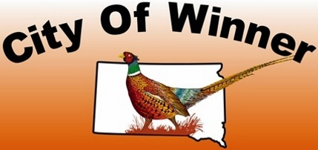

CITY OF WINNER SPECIAL ALCOHOLIC BEVERAGE APPLICATION

**APPLICANT**

This application is for special alcohol licenses to be applied for in conjunction with a special event to any civic, charitable, educational, fraternal, or veteran’s organization or any licensed licensee to be held in the City of Winner for a period not to exceed 15 consecutive days. No person or entity may be issued more than 20 special alcohol licenses per calendar year.

Name of Business or Organization: _____________________________________________________________

Contact Person: ___________________________________ Contact Phone No. _________________________

Business Address: _________________________________ Email Address: _____________________________

**TYPE OF LICENSE**

$30.00 Temp Malt Beverage and SD Farm Wine $25.00 Non-Profit Beer Garden

$100.00 On-Sale Special Event $0.00 (For donated alcohol)

**LOCATION WHERE ALCOHOL WILL BE SOLD/SERVED**

Date(s) of Event: ________________________________Name of Event: ________________________________

Location of Event: ____________________________________________ Hours of Event: __________________

CERTIFICATE: The undersigned applicant certified under the penalty of perjury, by law provided that all statements herein are true and correct; that the said applicants comply with all of the statutory requirements for this class of license being applied for and in addition agrees to permit agents of the Department of Revenue access to the licensed premises and records as provided in SDCL Title 35, and agrees that this application shall constitute a contract between applicant and the State of South Dakota entitling the same or any peace officers to inspect the premises, books and records at any time for the purpose of enforcing the provisions of Title 35 SDCL, as amended.

X_______________________________ X_________________________________________ ____________

Printed Name Applicant’s Signature Date

**For office use only:**

Application received (date and time):

Approved Denied Active Liquor License #:

Finance Officer Signature

Revised 4/27/20